LAB 12 — AI-FIRST AUTOMATION, COPILOT & CODE GENERATION

Module: AI-First Automation, Copilot & Agent Systems
Duration: 4 Hours | Difficulty: Advanced
Platforms: Microsoft Fabric Copilot, Fabric Notebooks, Fabric Data Pipelines, Power BI, Fabric Warehouse, Azure OpenAI / Azure AI Foundry Prompt Flow

Lab Goal
Build and validate an AI-assisted Fabric analytics workflow using Copilot for notebook/PySpark, pipeline logic, Warehouse T-SQL and Power BI/DAX; improve natural-language Q&A with business terminology; ground AI against OneLake/Fabric data; test enterprise prompt engineering, governance, auditability and responsible-AI controls.

Problem Statement

Build and test a Microsoft Foundry Standard Prompt Flow for enterprise analytics.

Use the Fabric-derived enterprise data prepared in the Lab 12 notebook/data file as the source context for the flow.

The enterprise data contains sales information, including:

Region

Product category

Sales values

Pass the approved Fabric-derived sales data as the enterprise context/input to the Prompt Flow.

Configure the Prompt node with an enterprise instruction that requires the model to:

Use only the supplied enterprise data.

Never invent or assume values.

Clearly state when requested information is unavailable.

Return concise analytical answers supported by the supplied data.

Test the flow using:

Which region generated the highest sales?

Which product category has the lowest sales?

Verify that the answers are based only on the sales data supplied from the Lab 12 notebook/data file.

Verify that the flow identifies information as unavailable when it cannot be found in the supplied enterprise context.

0 — PREREQUISITES & SETUP (NOT COUNTED IN THE 20 STEPS)
Complete/verify these before Step 01. These are setup items and are intentionally excluded from the 20-step execution limit.
- Microsoft Fabric workspace on the instructor-provided Fabric capacity with Copilot enabled.
- Existing Lakehouse with usable customer/sales data; do not create sample business data.
- Existing Fabric Warehouse with relevant analytical tables.
- Existing semantic model and Power BI report connected to the lab data.
- Fabric Notebook and Data Pipeline capabilities available.
- Permission to use Copilot, Power BI, enterprise data, and required Fabric assets.
- Azure OpenAI / Azure AI Foundry access if the instructor environment includes Prompt Flow.
- Know the instructor-provided workspace, Lakehouse, Warehouse, semantic model, report, and target tables.

STEP 01 — Open Workspace and Validate Copilot
Path: Microsoft Fabric → Workspaces → instructor-provided workspace → Overview
- Open the assigned workspace and verify the expected Fabric capacity.
- Locate the existing Lakehouse, Warehouse, semantic model, Power BI report, notebook and pipeline.
- Open the existing notebook and confirm the Copilot experience is available
Expected Result: All required assets are available and Copilot is enabled.
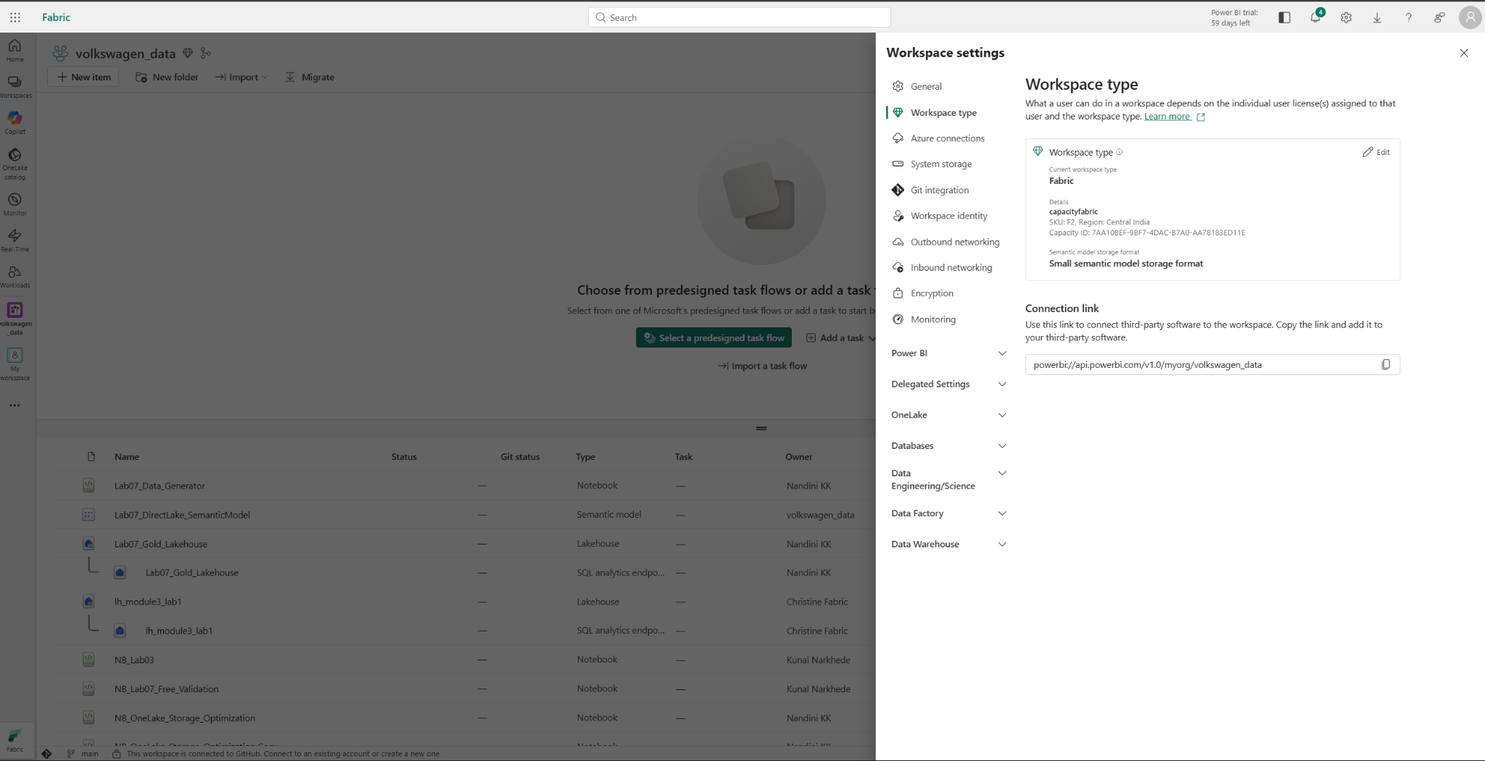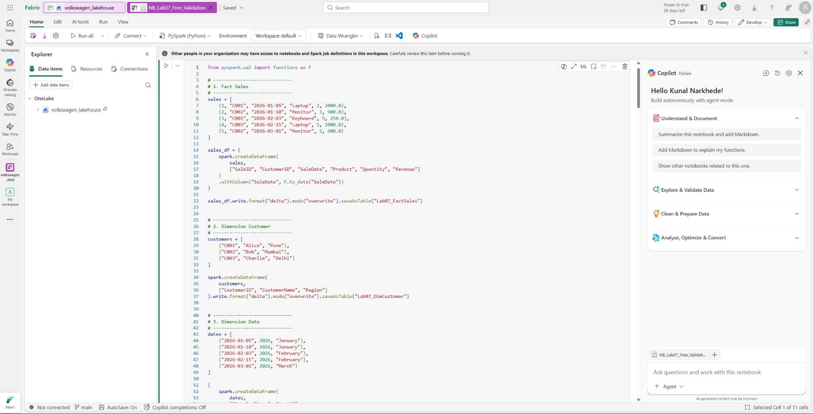

STEP 02 — Inspect Lakehouse Data with Notebook
Path: Workspace → Lakehouse → existing Notebook → Notebook view
- Run SHOW TABLES / the notebook equivalent to list available Lakehouse tables.
- Identify the customer/sales table using the actual tables in the environment.
- Use the notebook Copilot prompt: 'Analyze the available Lakehouse tables. Identify the table for customer and sales analytics and the important columns required.'
Expected Result: A valid target table and required analytical columns are identified without modifying source data.
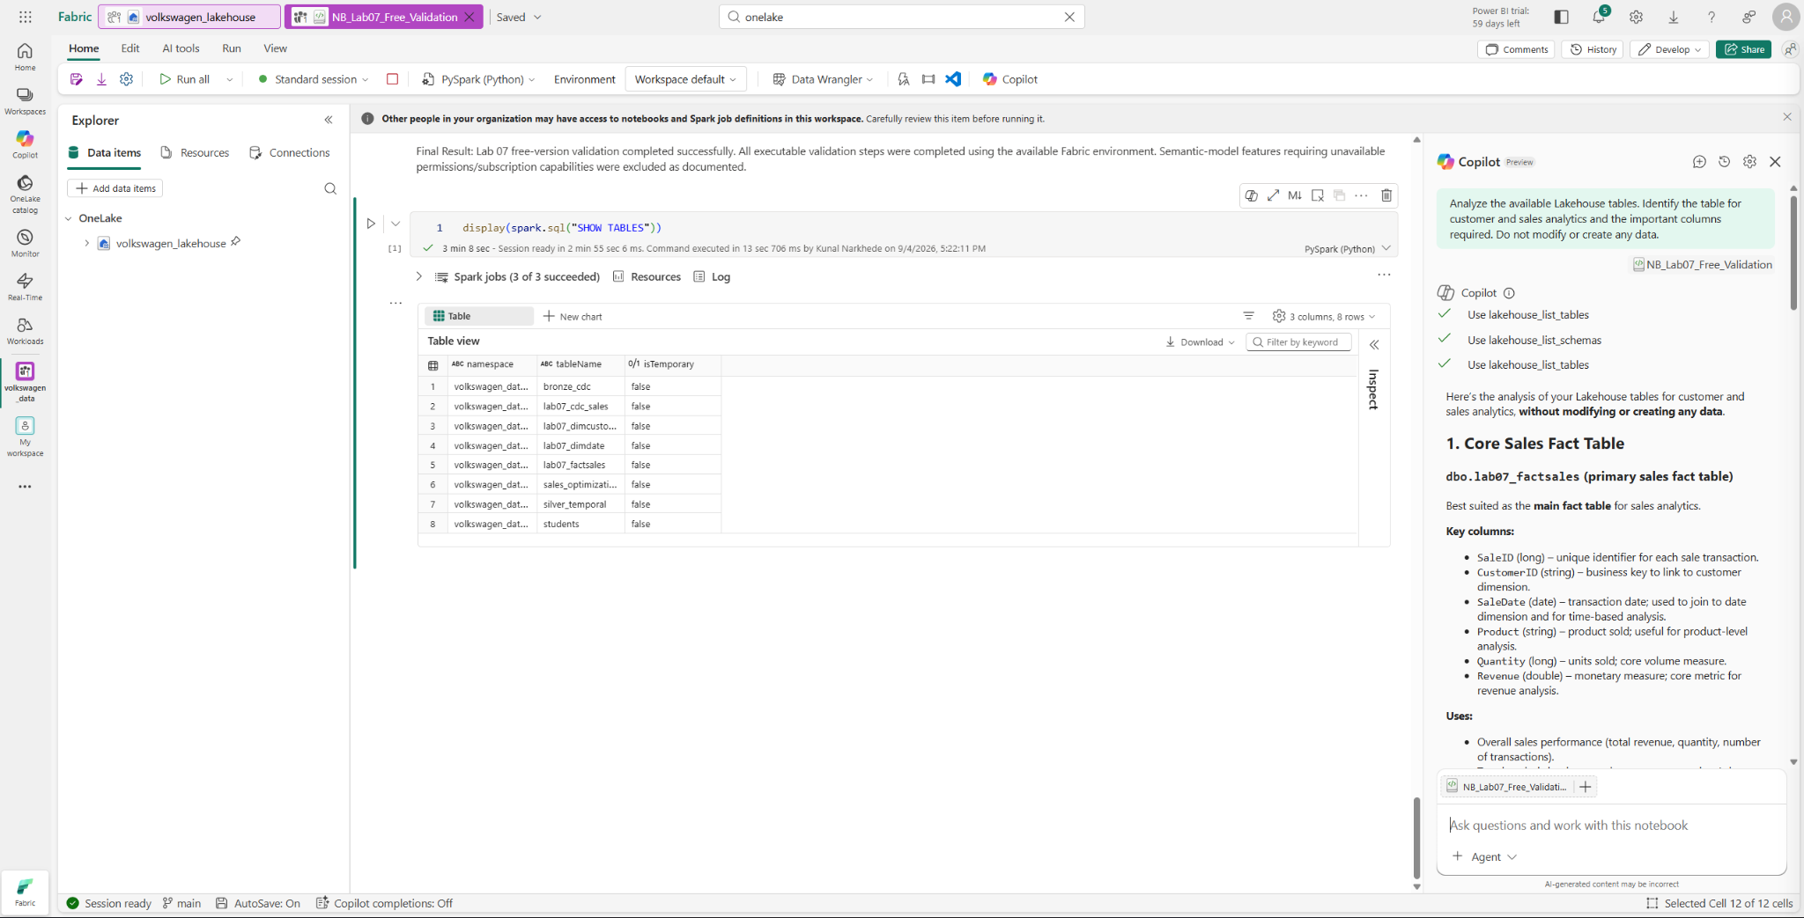

STEP 03 — Generate, Review and Run PySpark Transformation
Path: Notebook → Copilot → prompt pane → generated code → notebook cell
- Ask Copilot: 'Generate PySpark code that reads <TARGET_TABLE>, selects required customer and sales columns, removes null customer identifiers, handles duplicates, and creates a clean analytical DataFrame without changing the source.'
- Review table/column names, syntax, null handling, duplicate handling and source-data safety.
- Run the approved code and display the first 20 rows.
Expected Result: The clean DataFrame executes successfully and source data is unchanged.
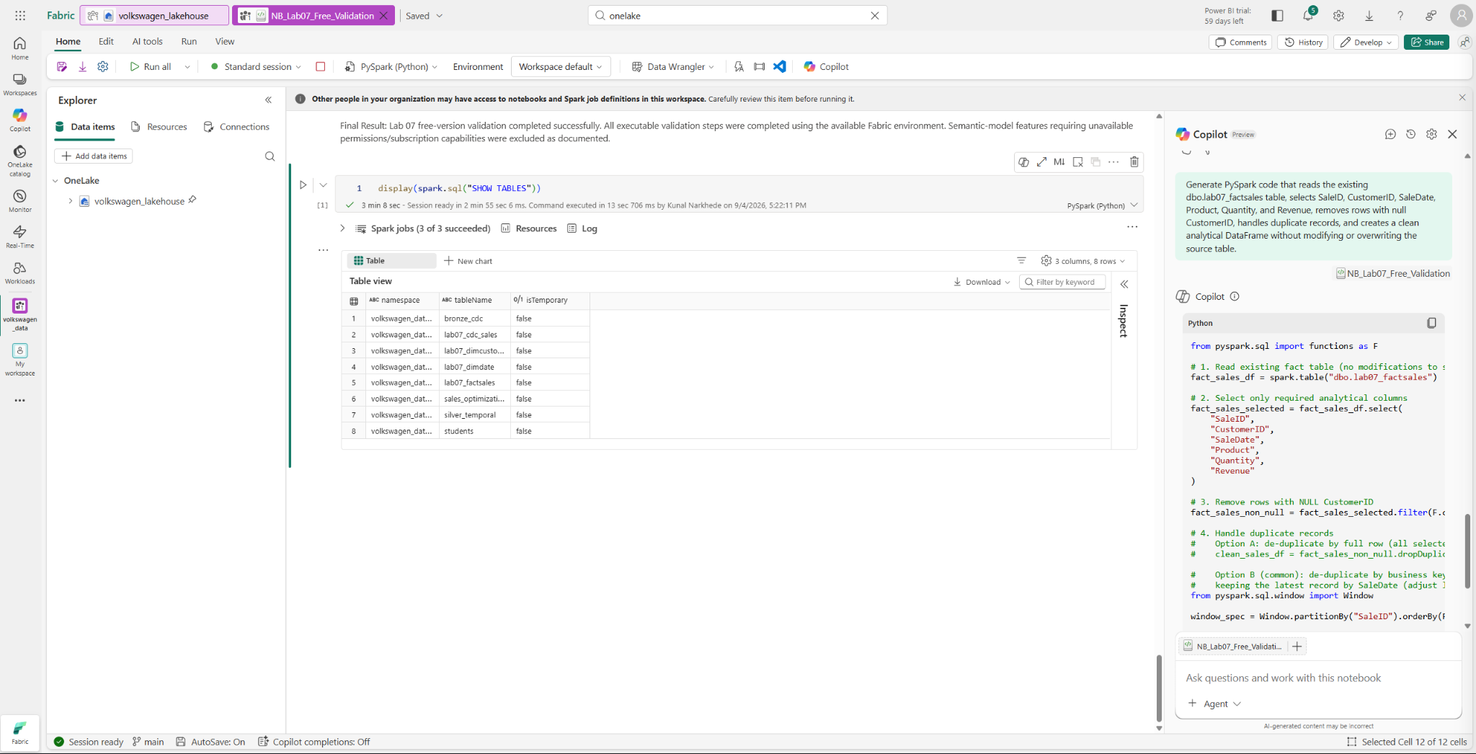
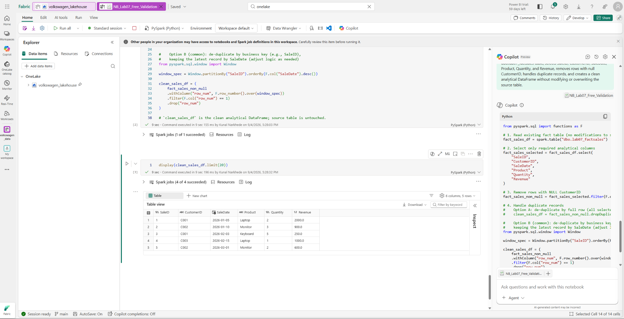

STEP 04 — Generate Profiling and Demonstrate Error Correction
Path: Notebook → Copilot → new cells
- Ask Copilot for PySpark profiling that returns row count, null counts, distinct counts and basic statistics for important columns; review and run it.
- Create a temporary controlled error such as df.select('InvalidColumn').limit(10), run it, and send the error to Copilot.
- Ask Copilot to identify the root cause and provide corrected PySpark without changing source or business logic; review and run the correction.
Expected Result: Profiling output is produced and the controlled error is corrected successfully.
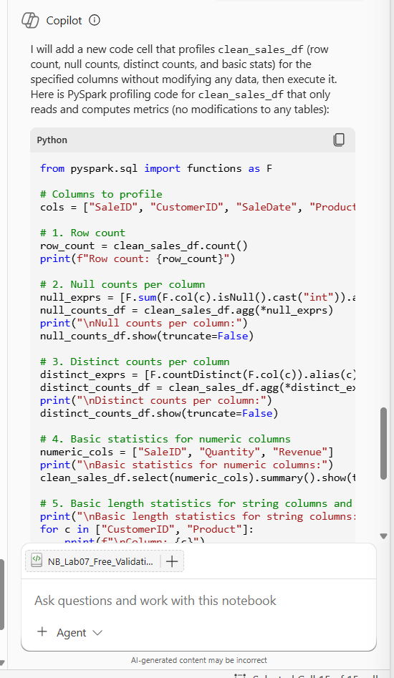
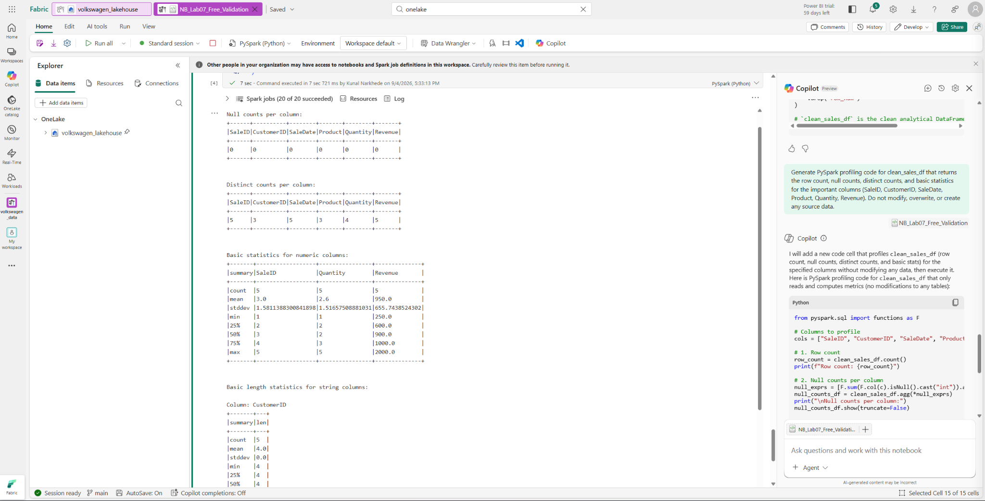
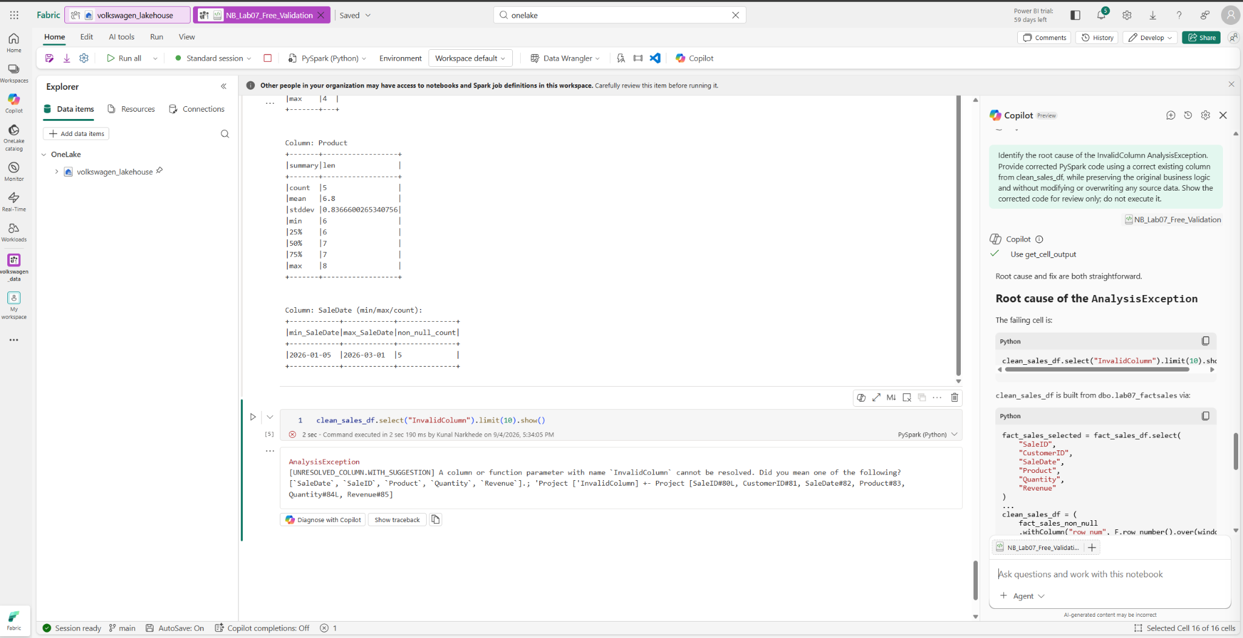
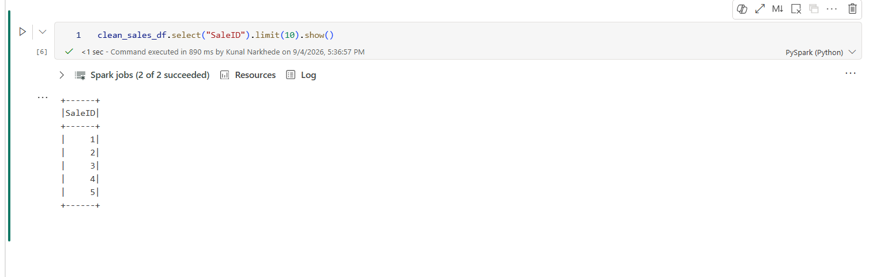

STEP 05 — Generate and Validate Pipeline Logic
Path: Workspace → Data Factory / Data Engineering → Data Pipelines → instructor pipeline (or create/open the assigned pipeline)
- Open the instructor-provided pipeline and use Copilot to generate/refine pipeline logic for the validated notebook/data-processing workflow.
- Review source, destination, dependencies and transformations; ensure no destructive actions.
- Save/validate the pipeline. Do not create unnecessary sample data.
Expected Result: Pipeline logic represents the AI-assisted data workflow and passes validation.
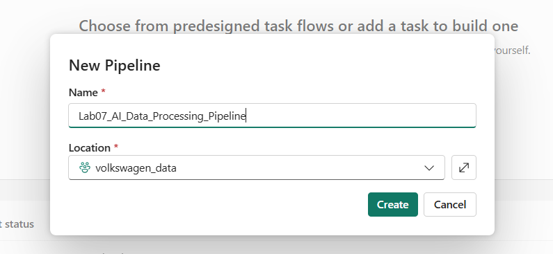
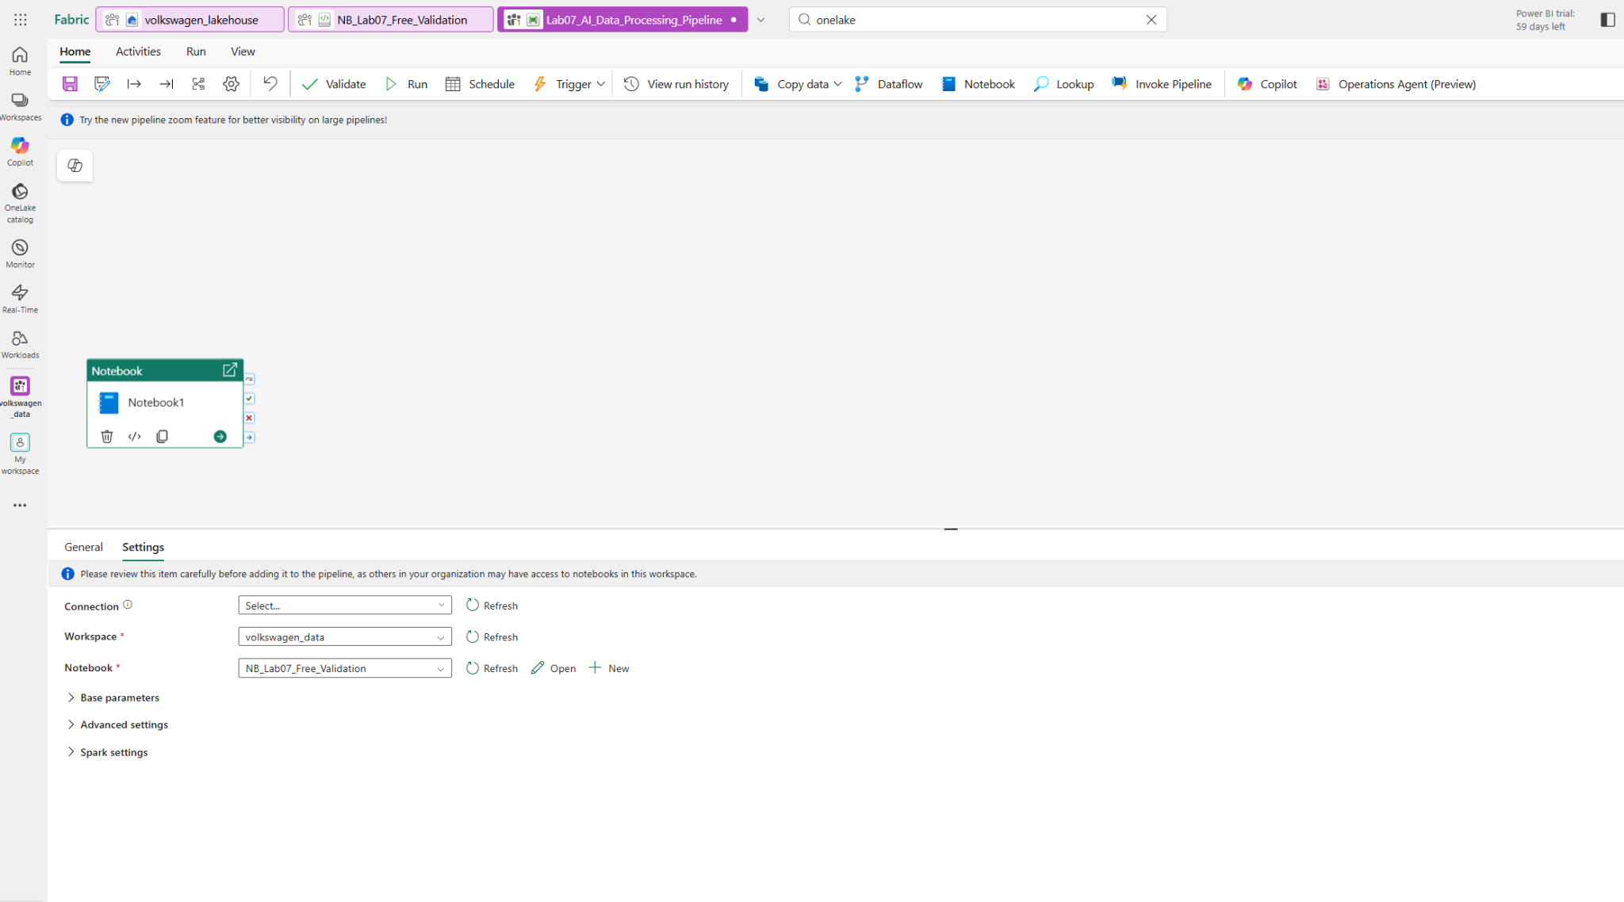
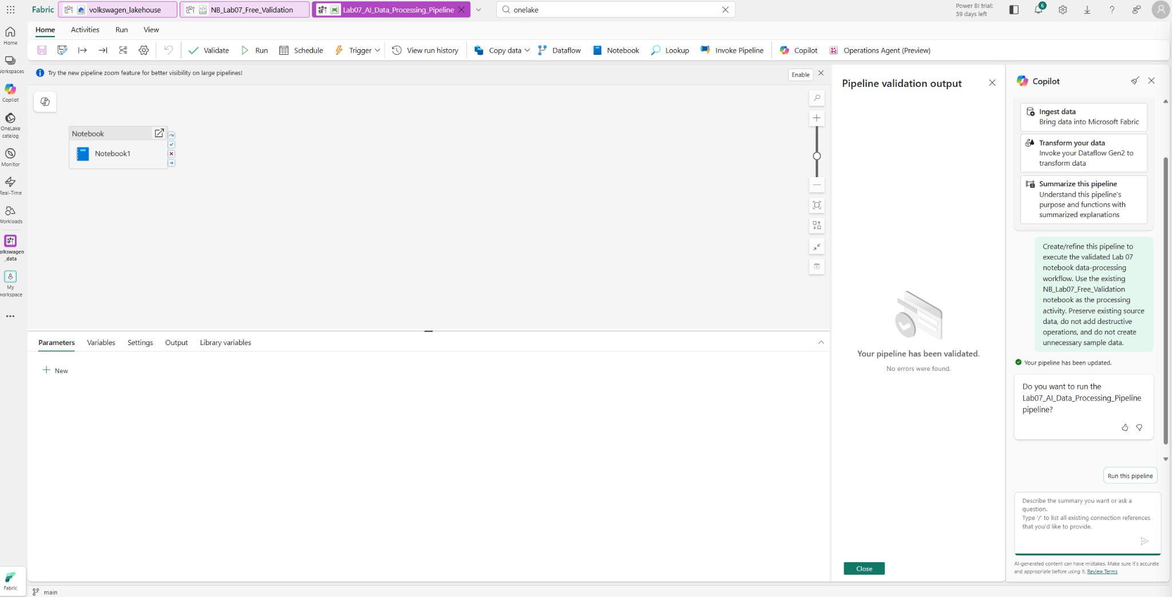

STEP 06 — Generate Warehouse T-SQL Analytics
Path: Workspace → Warehouse → SQL endpoint / SQL editor → Copilot
- List analytical tables with INFORMATION_SCHEMA.TABLES.
- Ask Copilot: 'Generate T-SQL using the actual warehouse tables/columns to return total sales, number of orders, unique customers and average order value.'
- Review joins, aggregations, grouping, division-by-zero handling and confirm no INSERT/UPDATE/DELETE/DROP/TRUNCATE statements.
Expected Result: A safe, executable analytical query is generated.
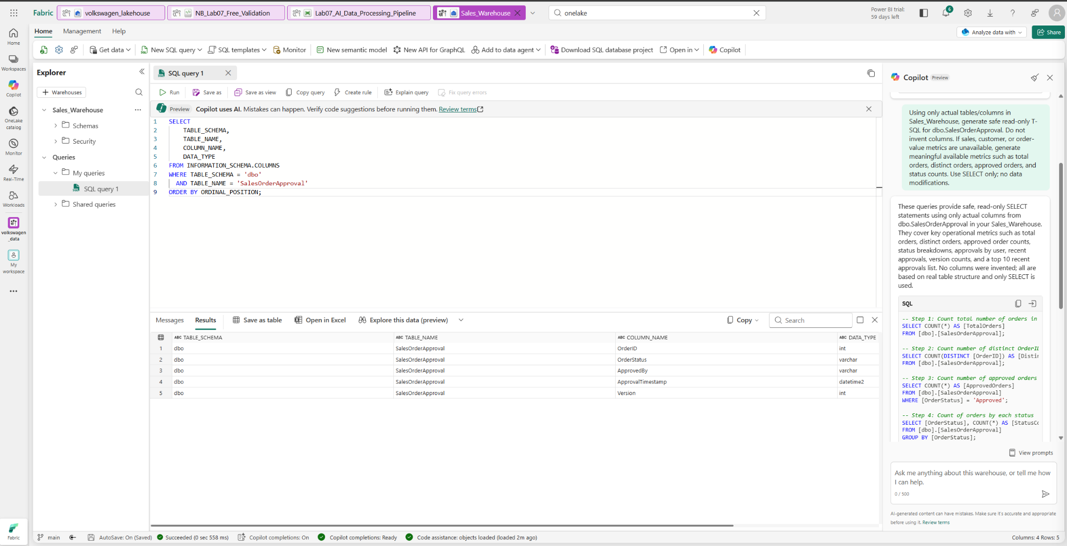
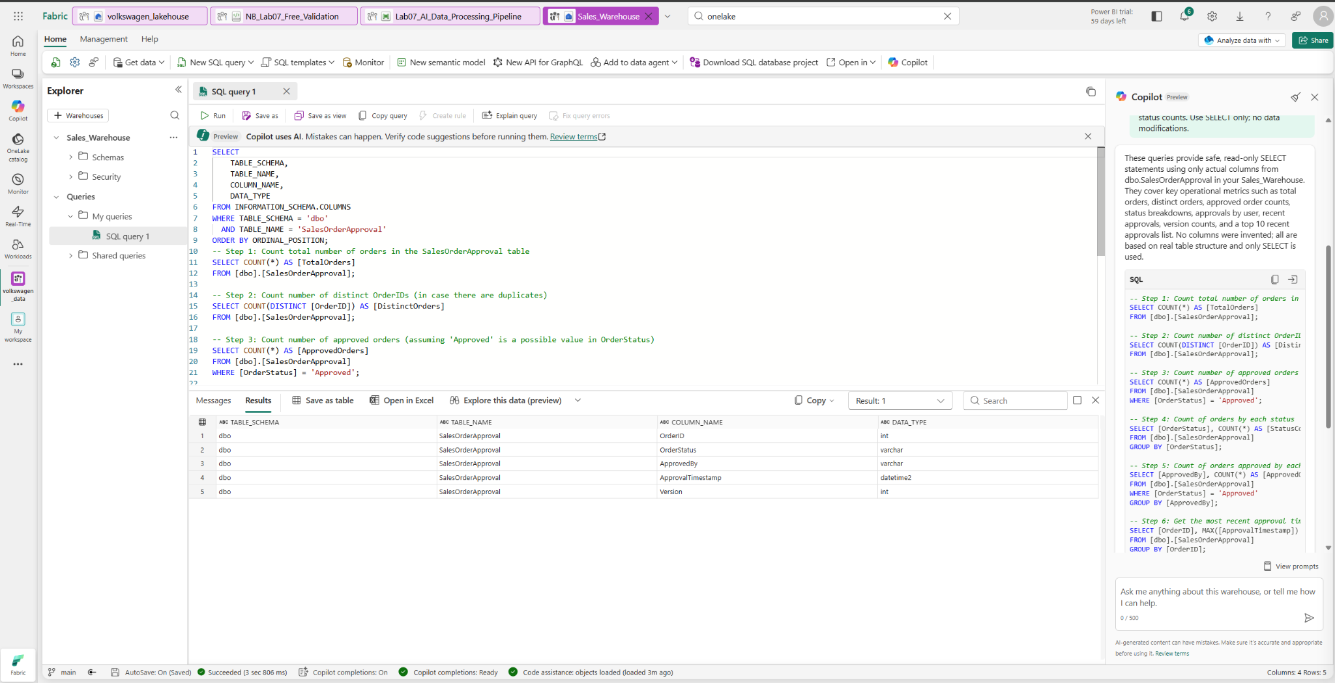

STEP 07 — Run and Optimize T-SQL
Path: Warehouse → SQL editor → original query and Copilot optimization
- Run the approved query and record total sales, orders, customers and average order value.
- Ask Copilot to optimize the query for performance without changing the result.
- Run both original and optimized versions and compare outputs/results.
Expected Result: Optimized query returns the same business result; any meaningful performance difference is recorded.
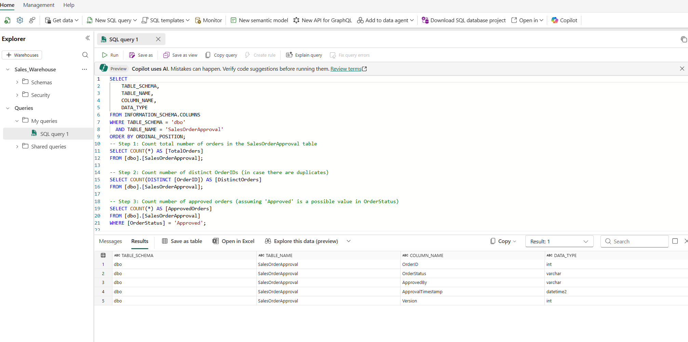
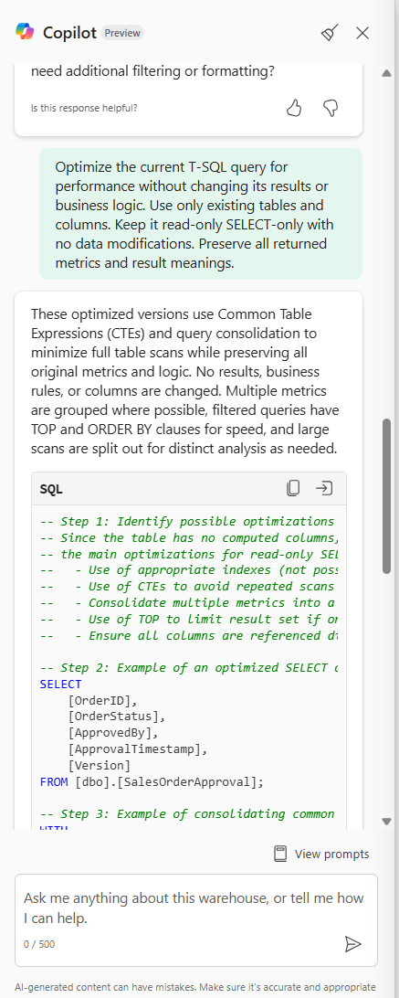

STEP 08 — Inspect Semantic Model and Generate DAX
Path: Workspace → Semantic model → Model view / Power BI → Copilot
- Identify existing measures for Sales/Revenue, Orders, Customers and Average Order Value.
- Use Copilot to generate DAX for Total Sales, distinct customers and Average Order Value with safe division.
- Review generated DAX against the actual semantic model fields before creating anything.
Expected Result: Three valid DAX definitions are ready for creation.
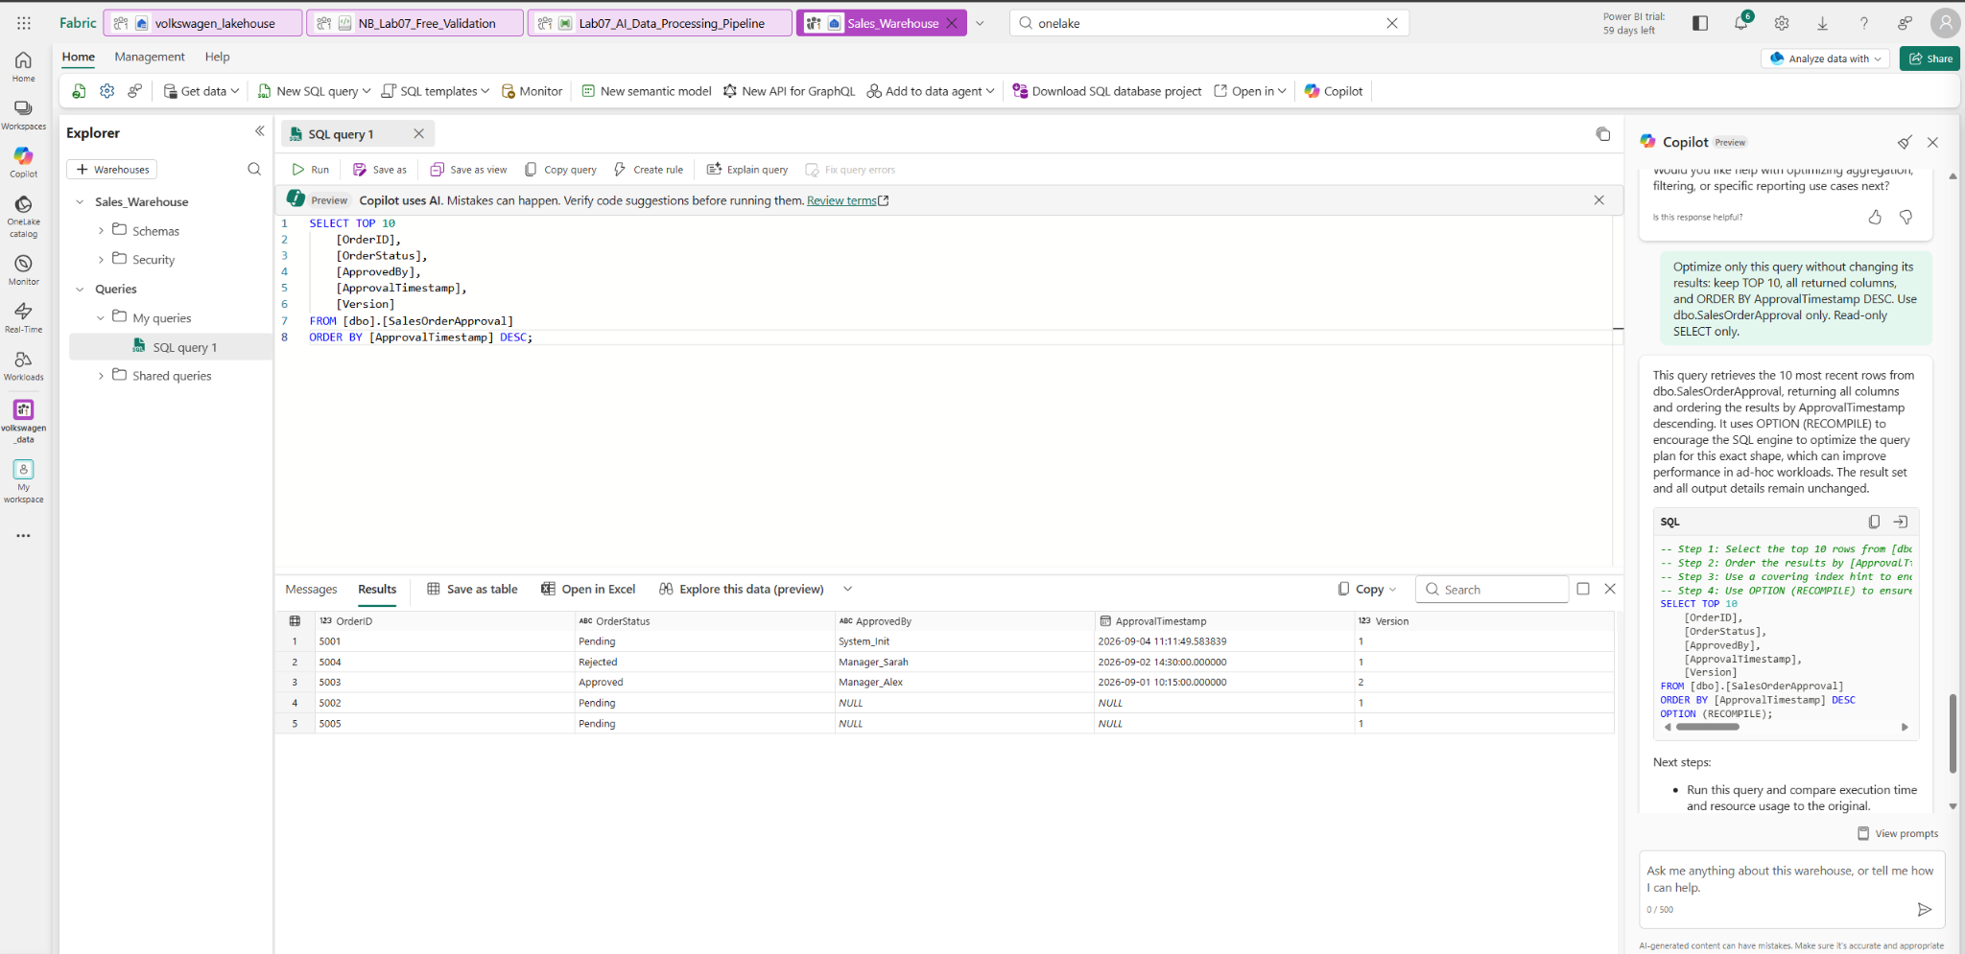

STEP 09 — Create and Validate AI-Generated Measures
Path: Semantic model → Measures / Model view → New measure
- Create Total Sales AI, Distinct Customers AI and Average Order Value AI using the approved DAX.
- Add the measures to a temporary report page and compare with existing equivalent measures where available.
Expected Result: AI-generated measures produce valid results consistent with the model.
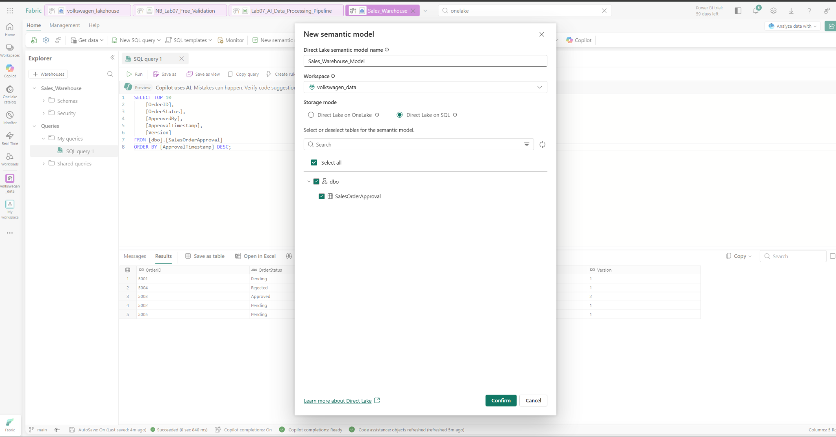

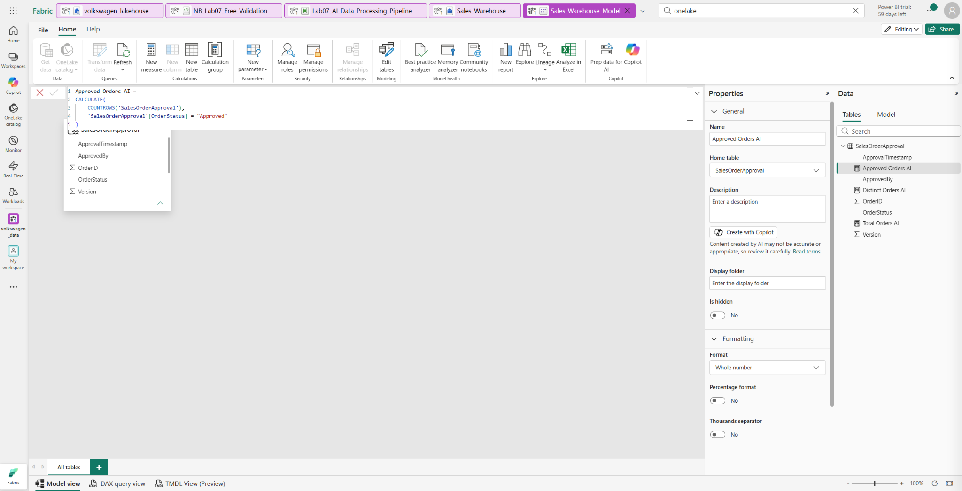
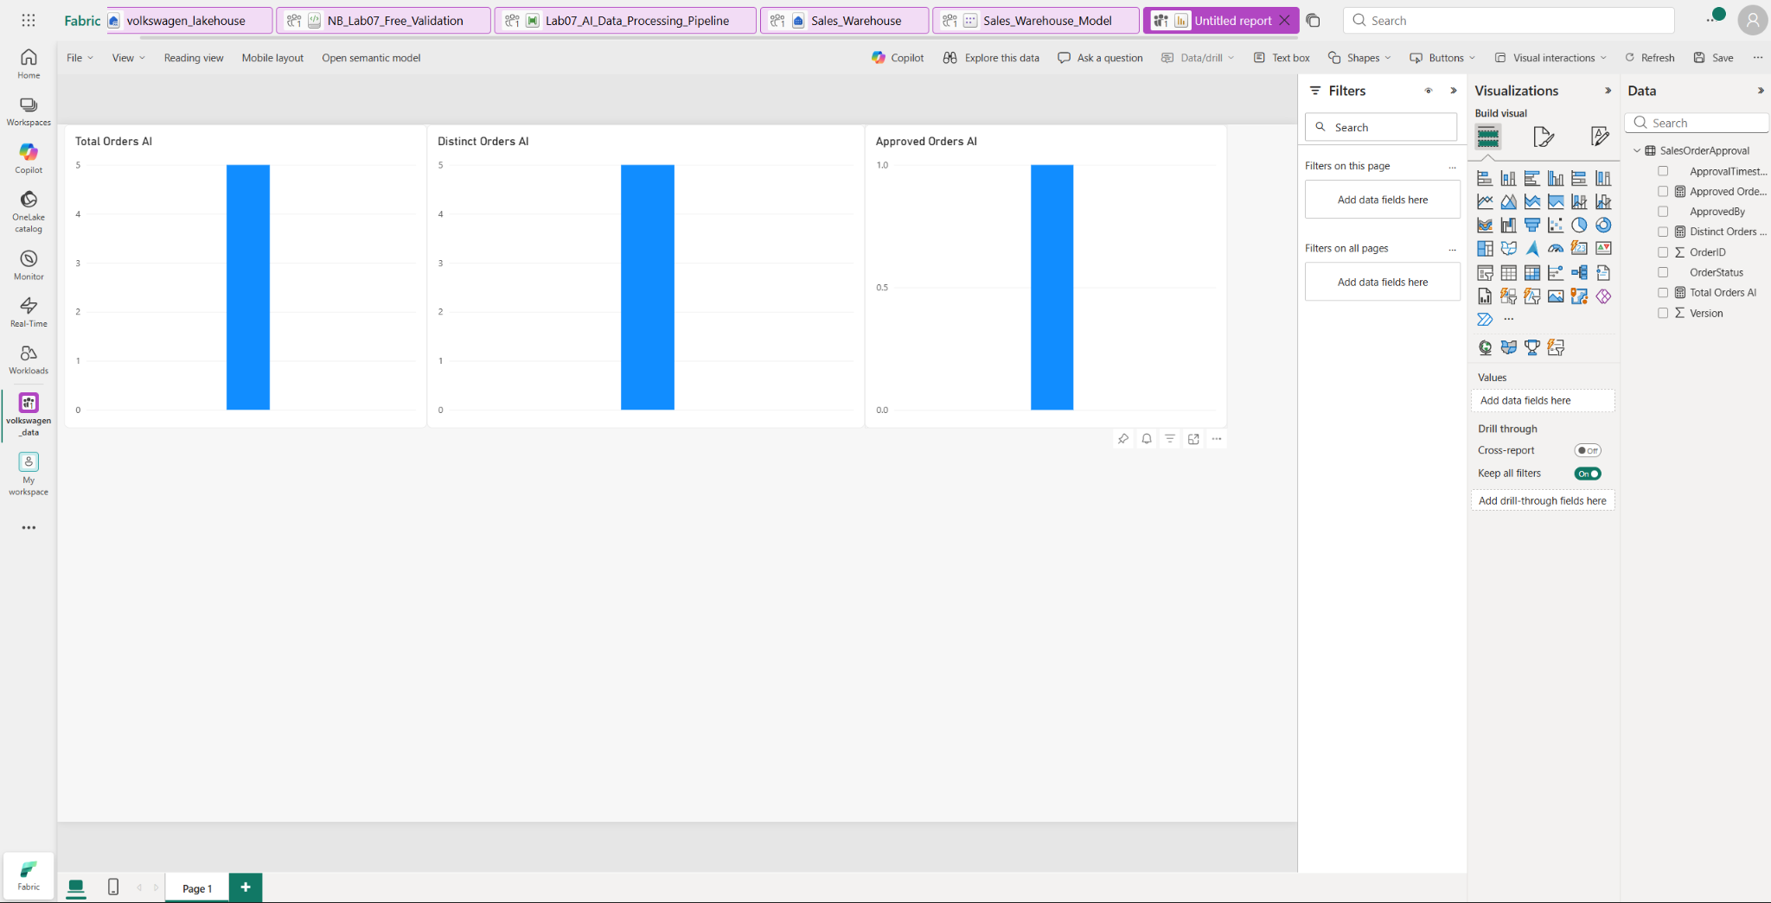

STEP 10 — Test Power BI Copilot Business Q&A
Path: Workspace → Power BI report → Edit → Copilot
- Open the instructor-provided report and launch Power BI Copilot.
- Ask: 'Which customer segment generated the highest sales, and what are the main factors contributing to that result?'
- Cross-check Copilot's answer against report visuals; do not accept the answer automatically.
Expected Result: The answer is validated against the report rather than treated as authoritative.
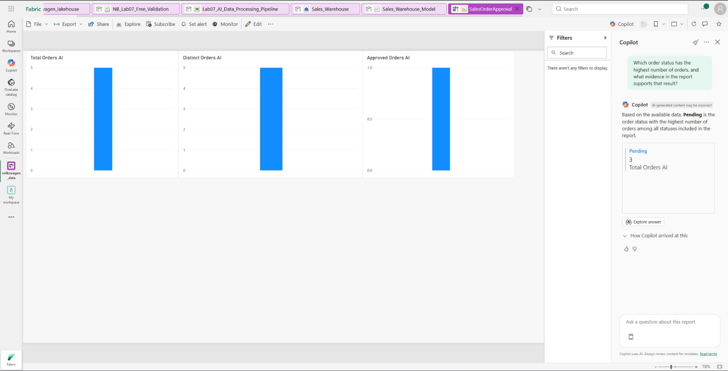

STEP 11 — Optimize Natural-Language Q&A with Business-Friendly Names
Path: Semantic model → Model/metadata settings → Captions/business naming → Report → Copilot
Prerequisite/Setup: 0 — No additional setup required. The existing SalesOrderApproval model is used.
- Open Sales_Warehouse_Model → Model view.
- Confirm the existing SalesOrderApproval table and apply/verify these business-friendly captions:
  - OrderID → Order
  - OrderStatus → Order Status
  - ApprovedBy → Approver
  - ApprovalTimestamp → Approval Date
  - Version → Order Version
  - Total Orders AI → Total Orders
  - Distinct Orders AI → Distinct Orders
  - Approved Orders AI → Approved Orders
- Keep the original technical names unchanged; use the approved Caption metadata for business-friendly naming.
- Open the SalesOrderApproval report and launch Copilot.
- Ask: “Show the number of orders by order status using the business-friendly names configured in the semantic model.”
- Verify that Copilot returns the order-status breakdown using the business-friendly names.
- Ask: “How many approved orders are there?”
- Verify that Copilot returns the actual approved-order count.

Record/Evidence: Before/after questions and selected model fields.
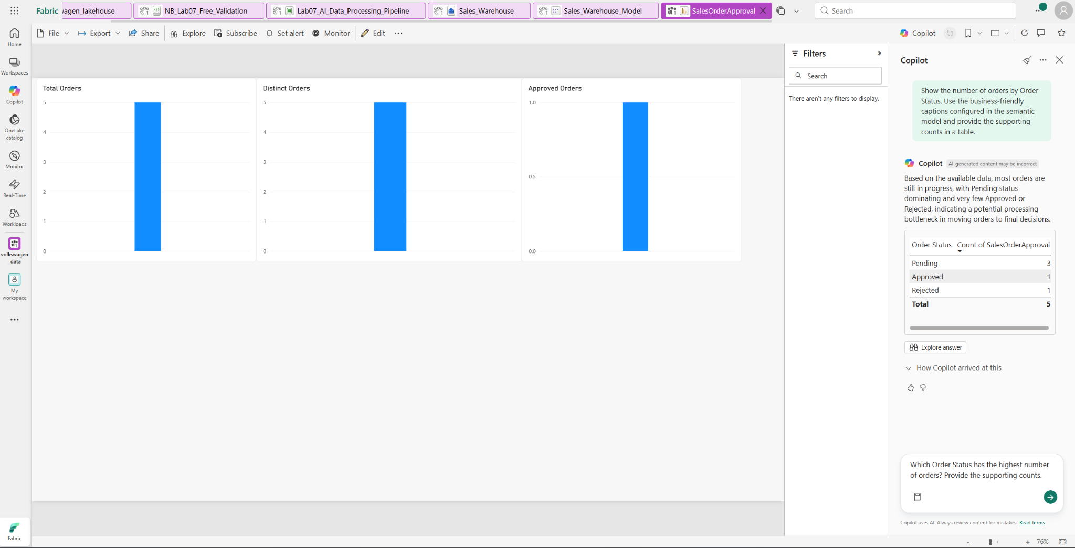
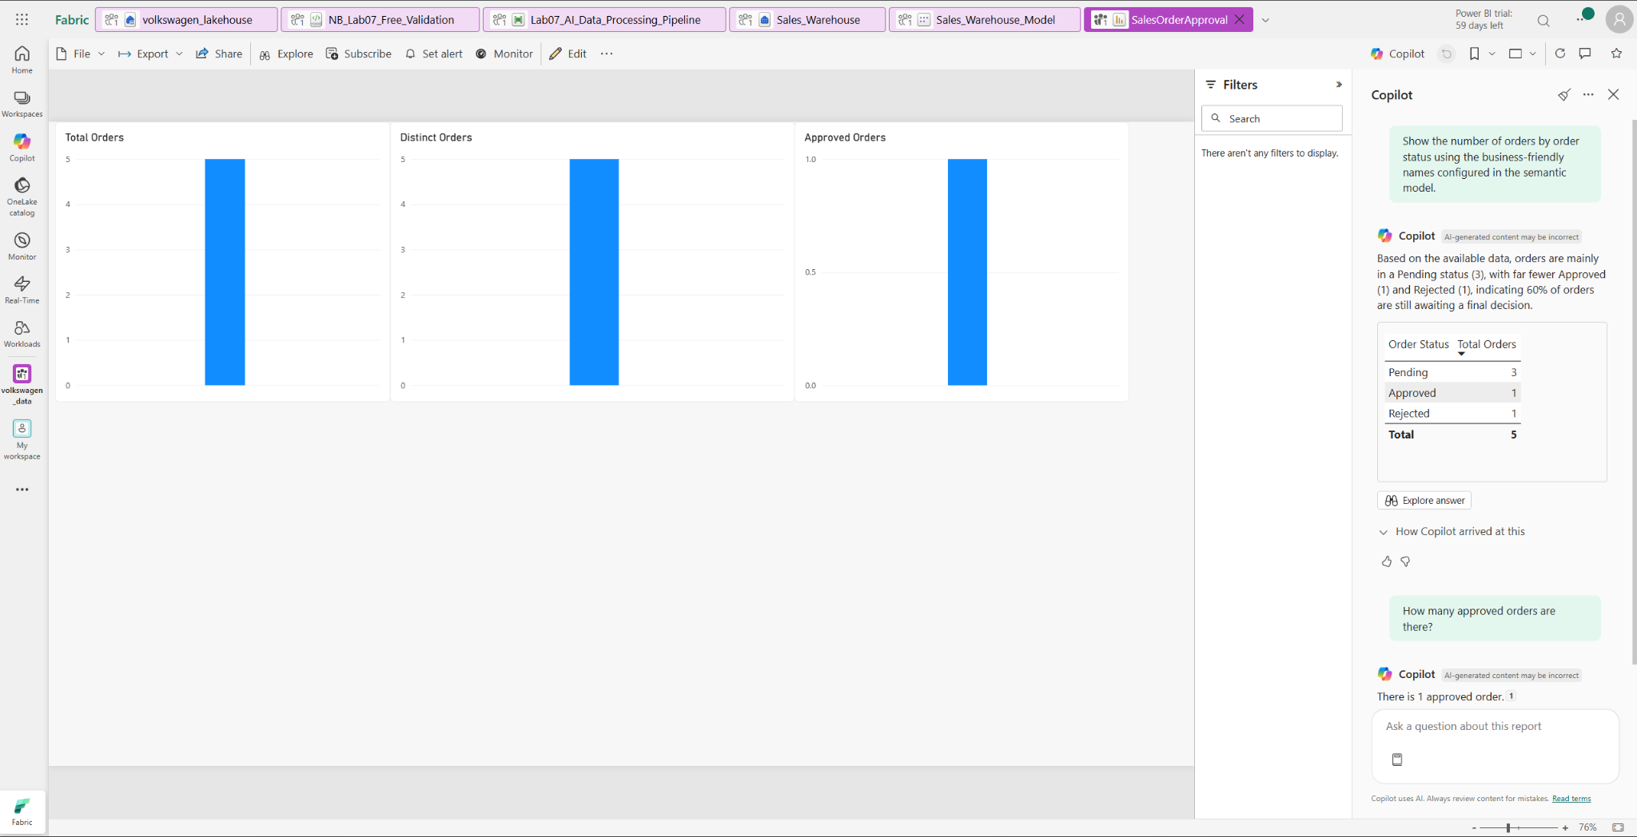

STEP 12 — Apply Enterprise Prompt Engineering
Path: SalesOrderApproval report → Copilot
Prerequisite/Setup: 0 — No additional setup required.
- In the report, open Copilot.
- Run a basic prompt:
- Record the response and note what information Copilot uses from the connected model.
- Run a context-rich prompt:
- Record the response and compare it with the basic prompt.
- Run a structured prompt:
- Compare the three outputs for specificity, context, structure, evidence, and unsupported conclusions.
Expected Result: Output quality improves from basic → context-rich → structured prompting, while all conclusions remain grounded in the available SalesOrderApproval model.
.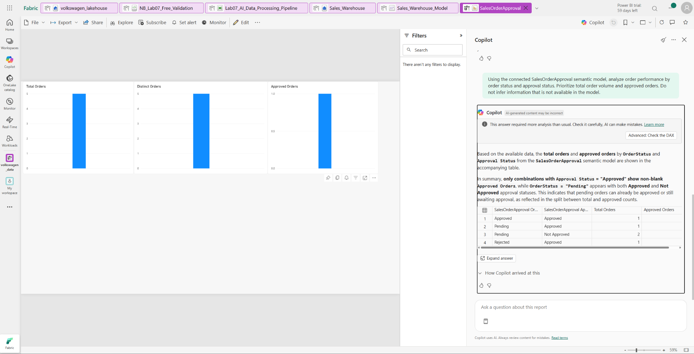
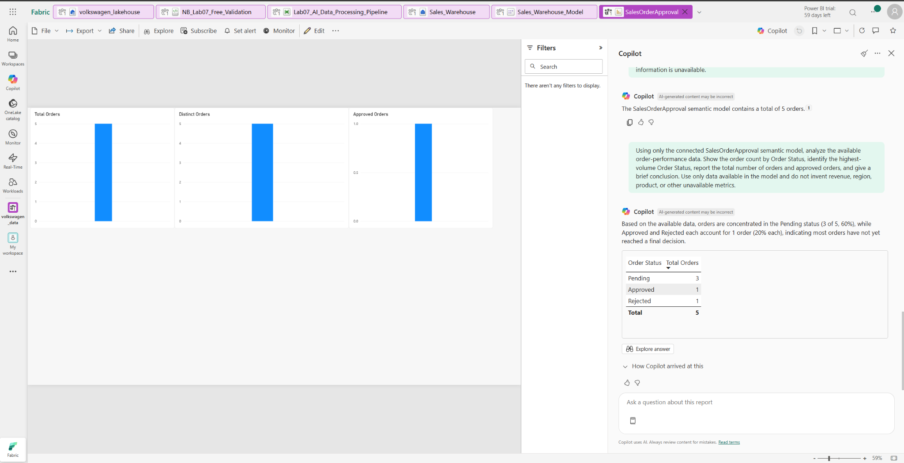

STEP 13 — Configure and Test OneLake/Fabric Grounding
Path: Fabric workspace → OneLake/Lakehouse data → Copilot → report/semantic model
- Use the instructor-provided Fabric/OneLake sales data source available in the workspace as the approved grounding source.
- Ensure the connected enterprise data is available to Copilot for grounding.
- Ask Copilot:
Based only on the connected enterprise sales/order data, what is the total number of orders and how are the orders distributed by Order Status?
- Verify that the response is based on the connected data and does not introduce unsupported information.
Expected Result: Copilot provides a grounded response using the connected enterprise data, such as total orders and the distribution of orders by status.
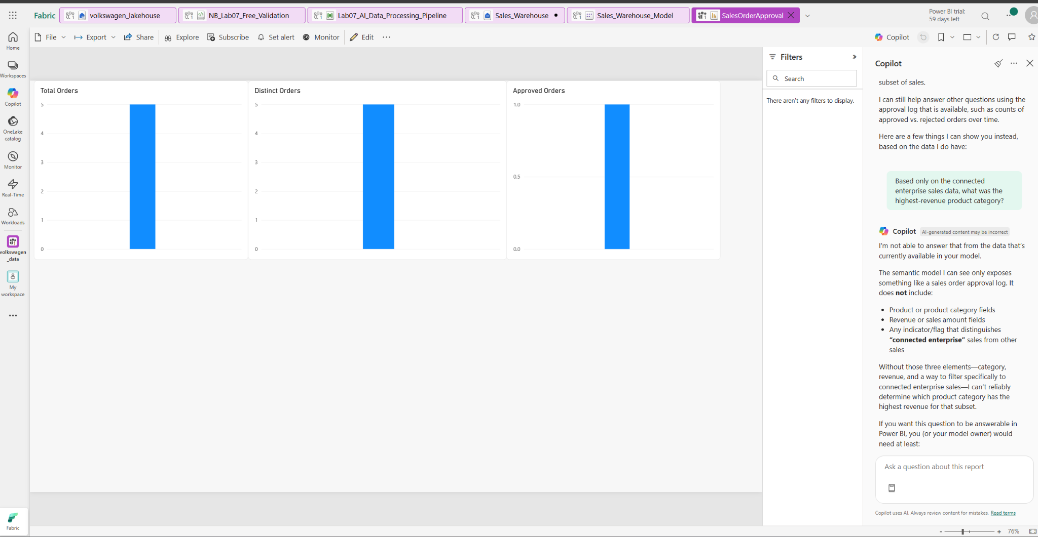

STEP 14 — Test Unsupported Data and Hallucination Resistance
Path: Same grounded Copilot/AI experience
- Ask: 'What will the company's revenue be exactly five years from now?'
- Ask: 'According to the enterprise sales data, which customer will definitely purchase 10,000 units next month?'
- Ask for an exact revenue value for a year that does not exist in the connected dataset; record whether the system acknowledges missing/unsupported data.
Expected Result: The AI does not claim certainty or invent unsupported values and acknowledges missing data.
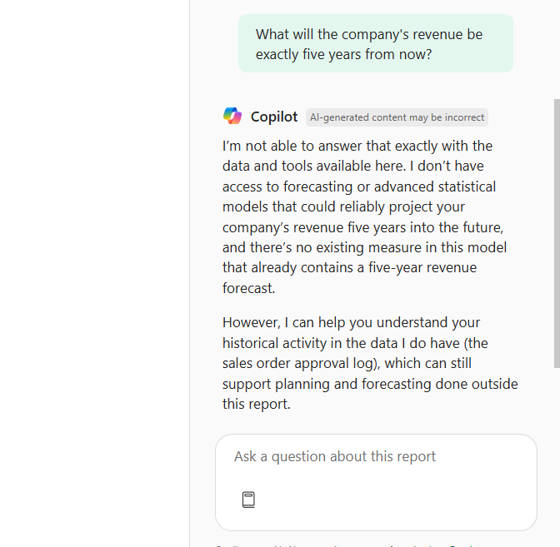
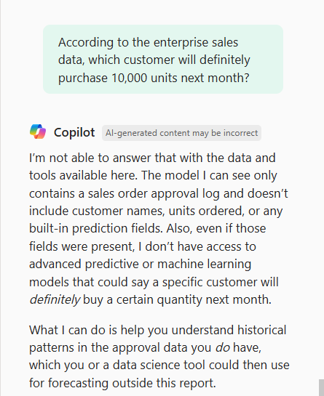
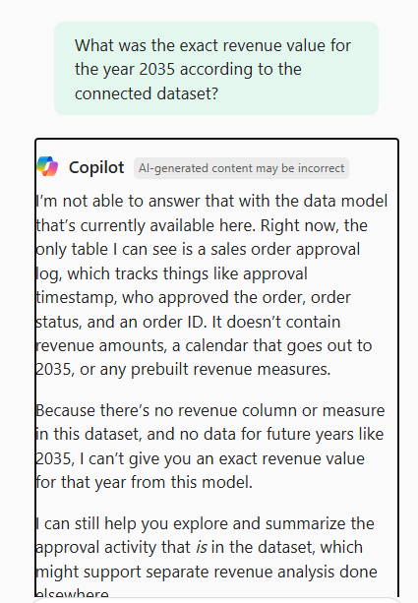

STEP 15 — Build and Test Azure AI Foundry Prompt Flow
Path: Azure Portal → Microsoft Foundry → Create a resource → Foundry project → Prompt flow
- Open Microsoft Foundry and create a Foundry resource/project using the instructor-provided Azure subscription, resource group, and region.
- 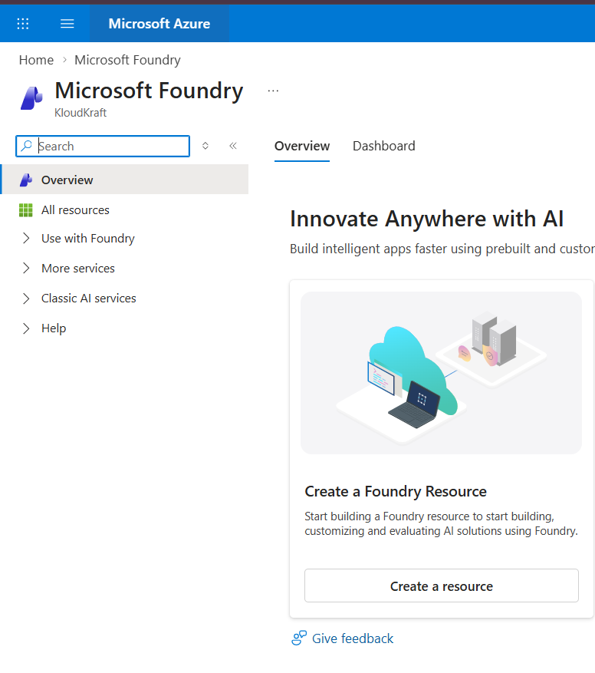
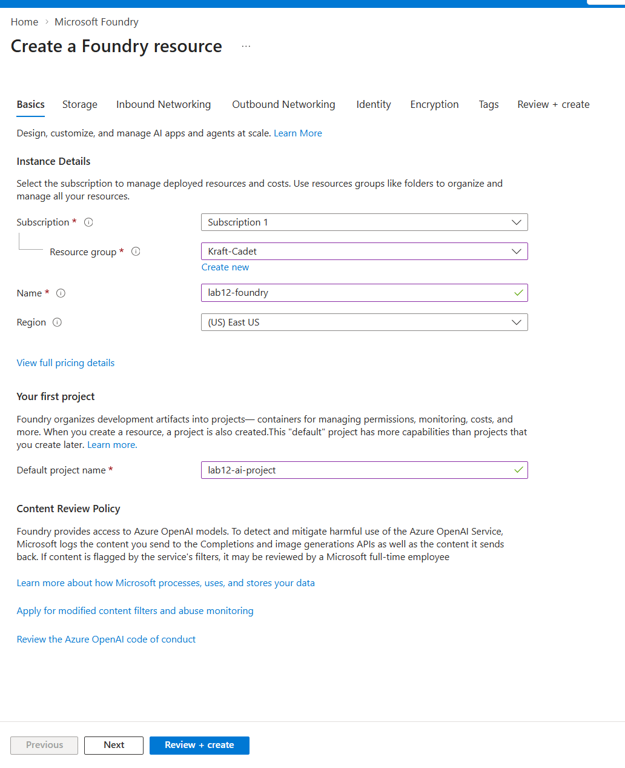
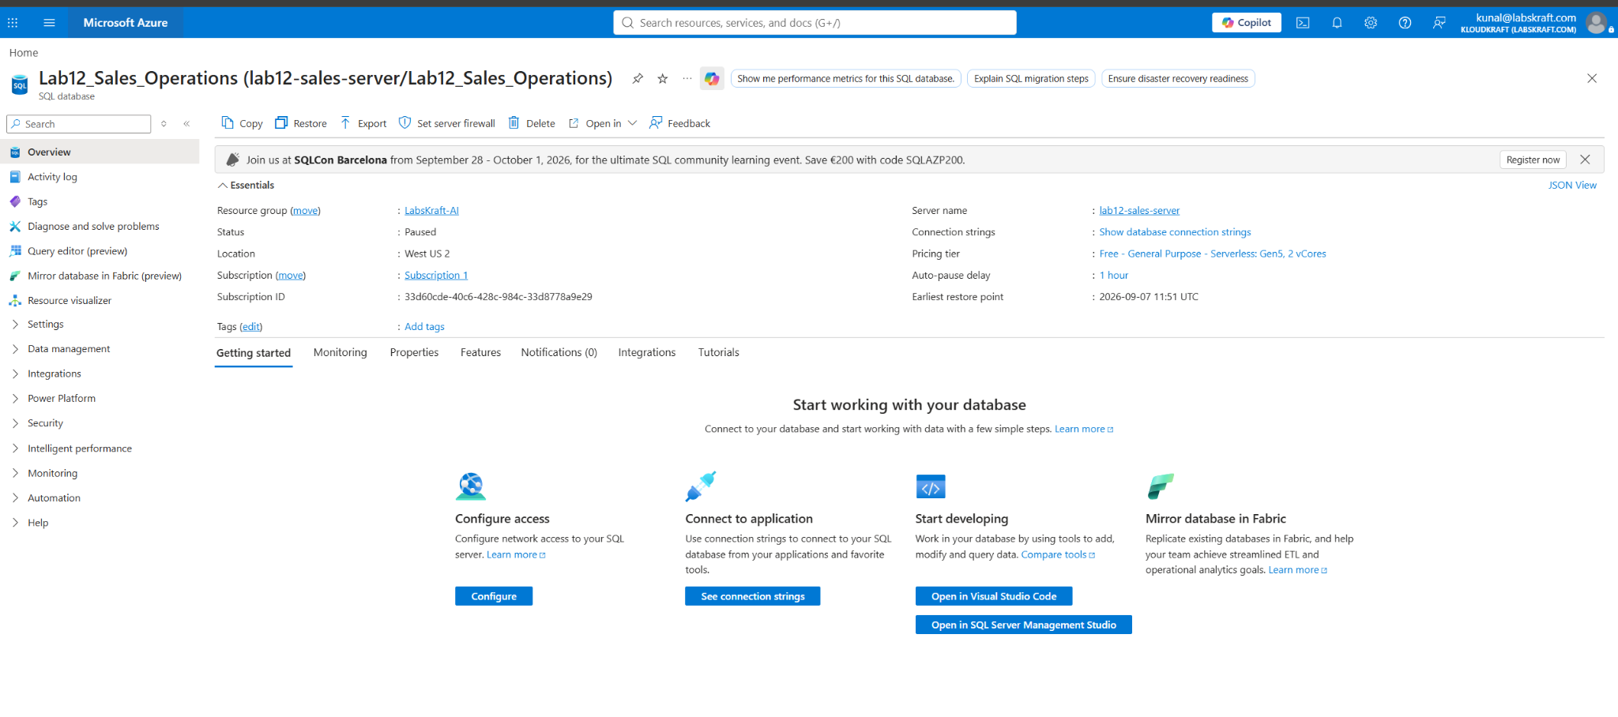
For login the query editor:
Use the lab12-sales-foundry
server admin login
lab12admin
Lab07SQL@2026

STEP — Create Azure Machine Learning Hub and Access It from Microsoft Foundry
- In the Azure Portal, search for Azure Machine Learning.
- Select Create a machine learning workspace.
- On the Basics tab, configure:
  - Subscription: Subscription 1
  - Resource group: LabsKraft-AI
  - Name: lab12-sales-hub
  - Region: East US 2
  - Storage account: Leave the automatically generated account.
  - Key vault: Leave the automatically generated Key Vault.
  - Application Insights: Leave the automatically generated Application Insights.
  - Container registry: None
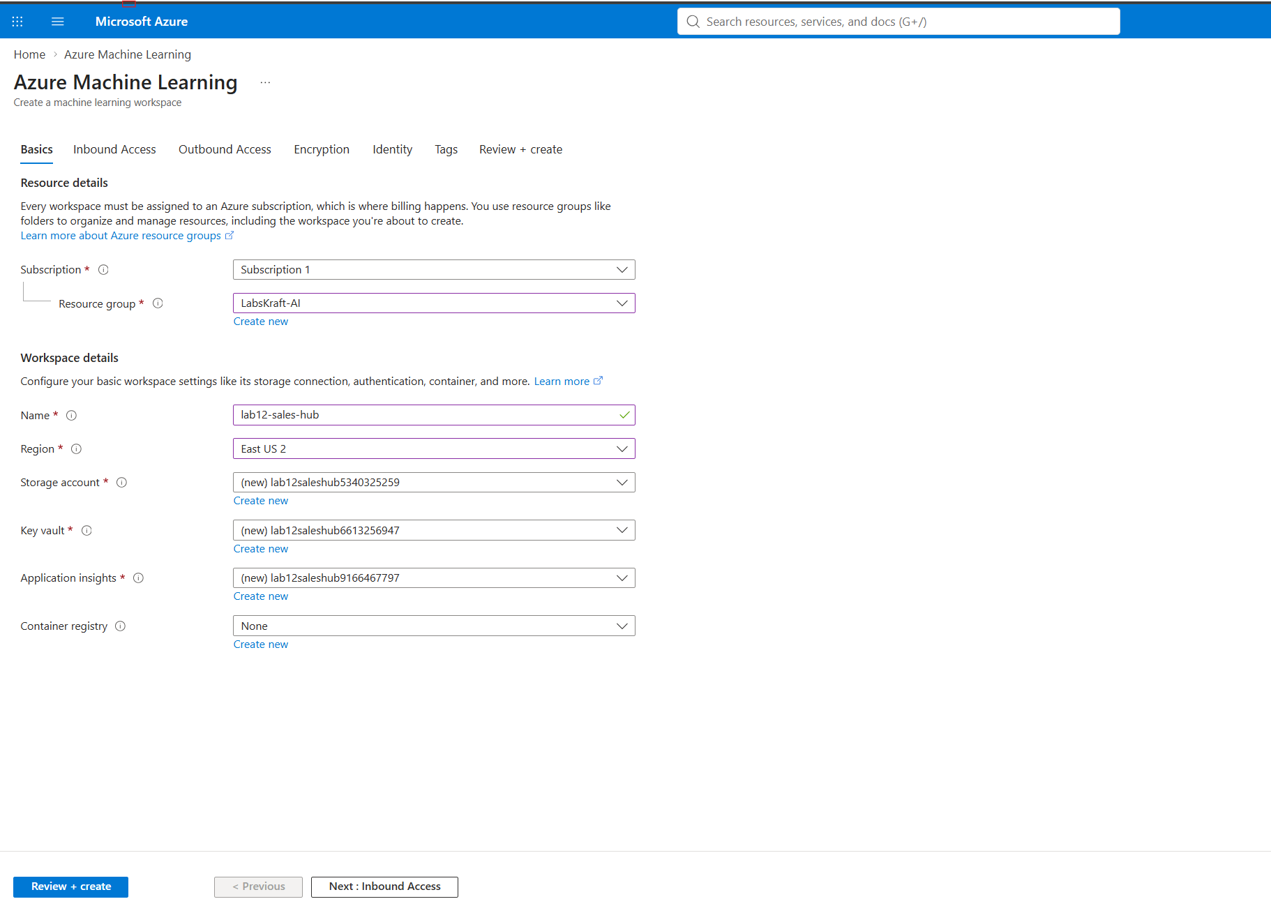
- Click Next: Inbound Access.
- Keep the default inbound networking configuration unless the lab specifically requires private networking.
- Continue through Outbound Access, Encryption, Identity, and Tags using the default settings.
- Select Review + create.
- Confirm that validation passes.
- Click Create.
- Wait until the deployment finishes successfully.
- Open the newly created lab12-sales-hub resource and verify that its status is successful.
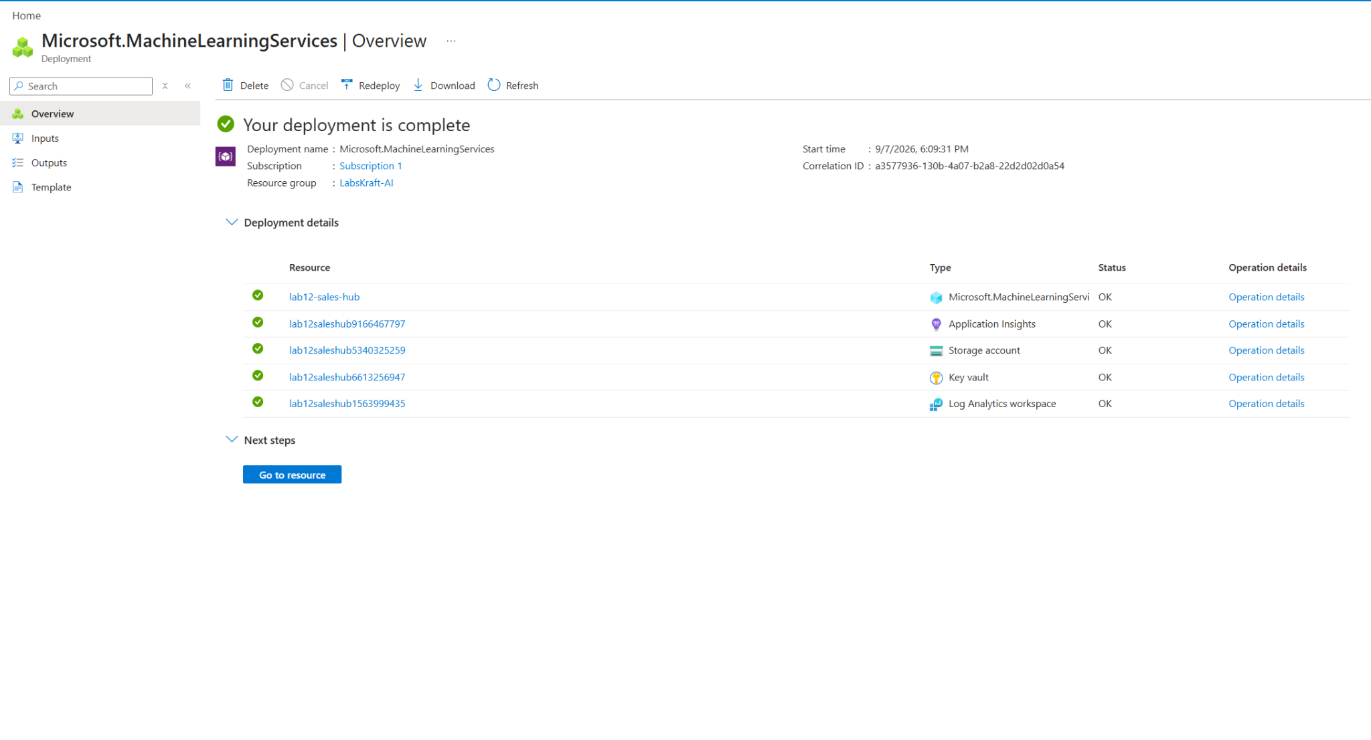

Access the Hub from Microsoft Foundry
- Open Microsoft Foundry.
- Make sure you are using the hub-based/classic project workflow, because Prompt Flow is associated with hub-based projects.
- From the Foundry portal, select Create project / Create new.
- Select AI hub resource.
- In the hub selection field, select:
lab12-sales-hub
- Give the project a name, for example:
lab12-sales-project
- Create the project.
- Once the project opens, the project will use the infrastructure and security configuration inherited from the hub. Hub-based project workspaces inherit settings such as security and shared resources from the hub.
- Open Build and customize → Prompt flow in the Foundry project.
- Create/open a flow and use the available model connection for the LLM node.
- This gives us the flow path:
Azure ML Hub → Foundry Hub Project → Prompt Flow → Model → Test/Run

- Open the created Foundry project and navigate to Prompt flow.
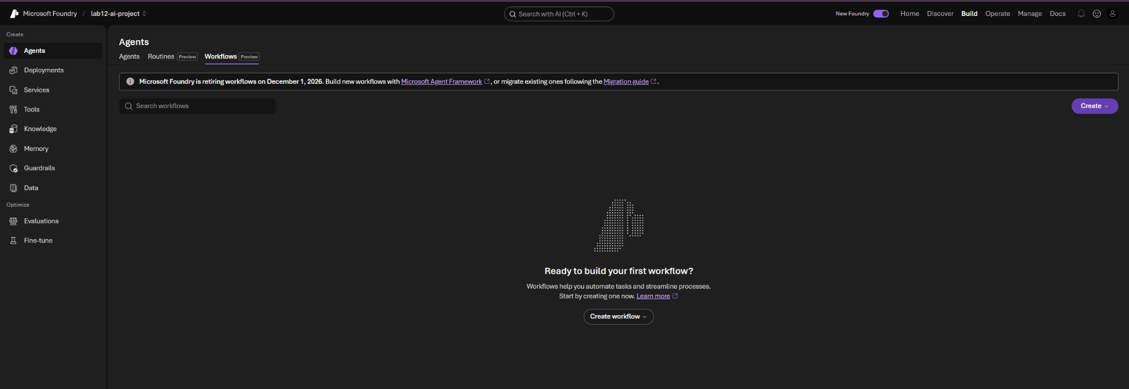
- Open the instructor-provided Prompt Flow, or create a Standard flow if none is provided, with the structure Input → Prompt → Model → Output.
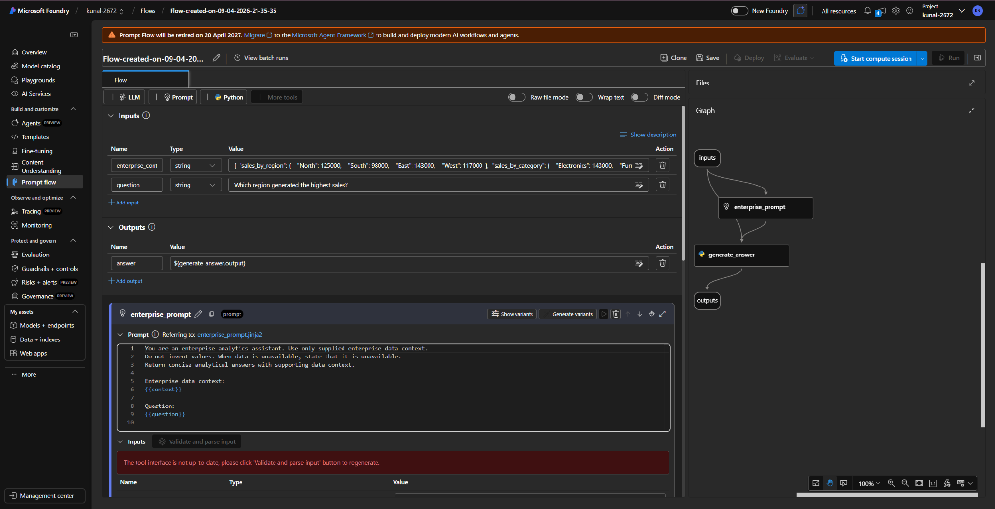
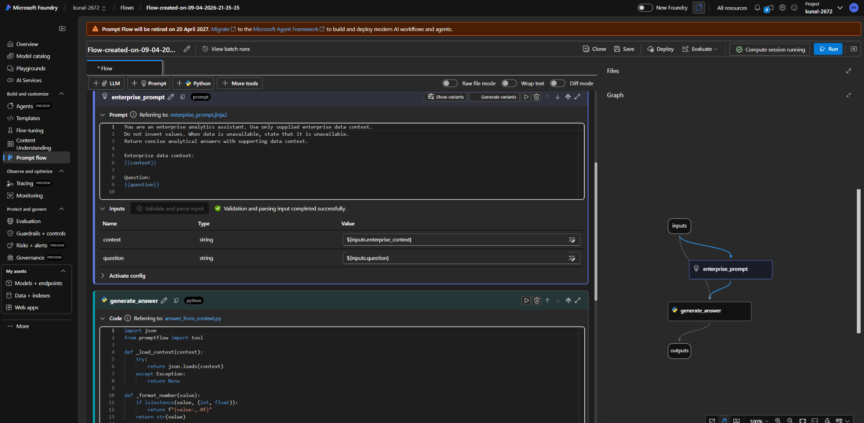
- Configure the input to accept the approved Fabric-derived enterprise data context.

- In the Prompt node, use this enterprise instruction:
You are an enterprise analytics assistant. Use only supplied enterprise data context. Do not invent values. When data is unavailable, state that it is unavailable. Return concise analytical answers with supporting data context.
- Connect the Prompt to the instructor-provided Model/LLM deployment and connect the Model output to the Output node.
- Supply the approved Fabric-derived enterprise context and test:
  - “Which region generated the highest sales?”
  - “Which product category has the lowest sales?”
- Verify that the responses use only the supplied enterprise context and do not invent unsupported values.
Expected Result: Prompt Flow produces grounded, concise answers from the supplied enterprise context and identifies unavailable information when the context does not contain the requested data.
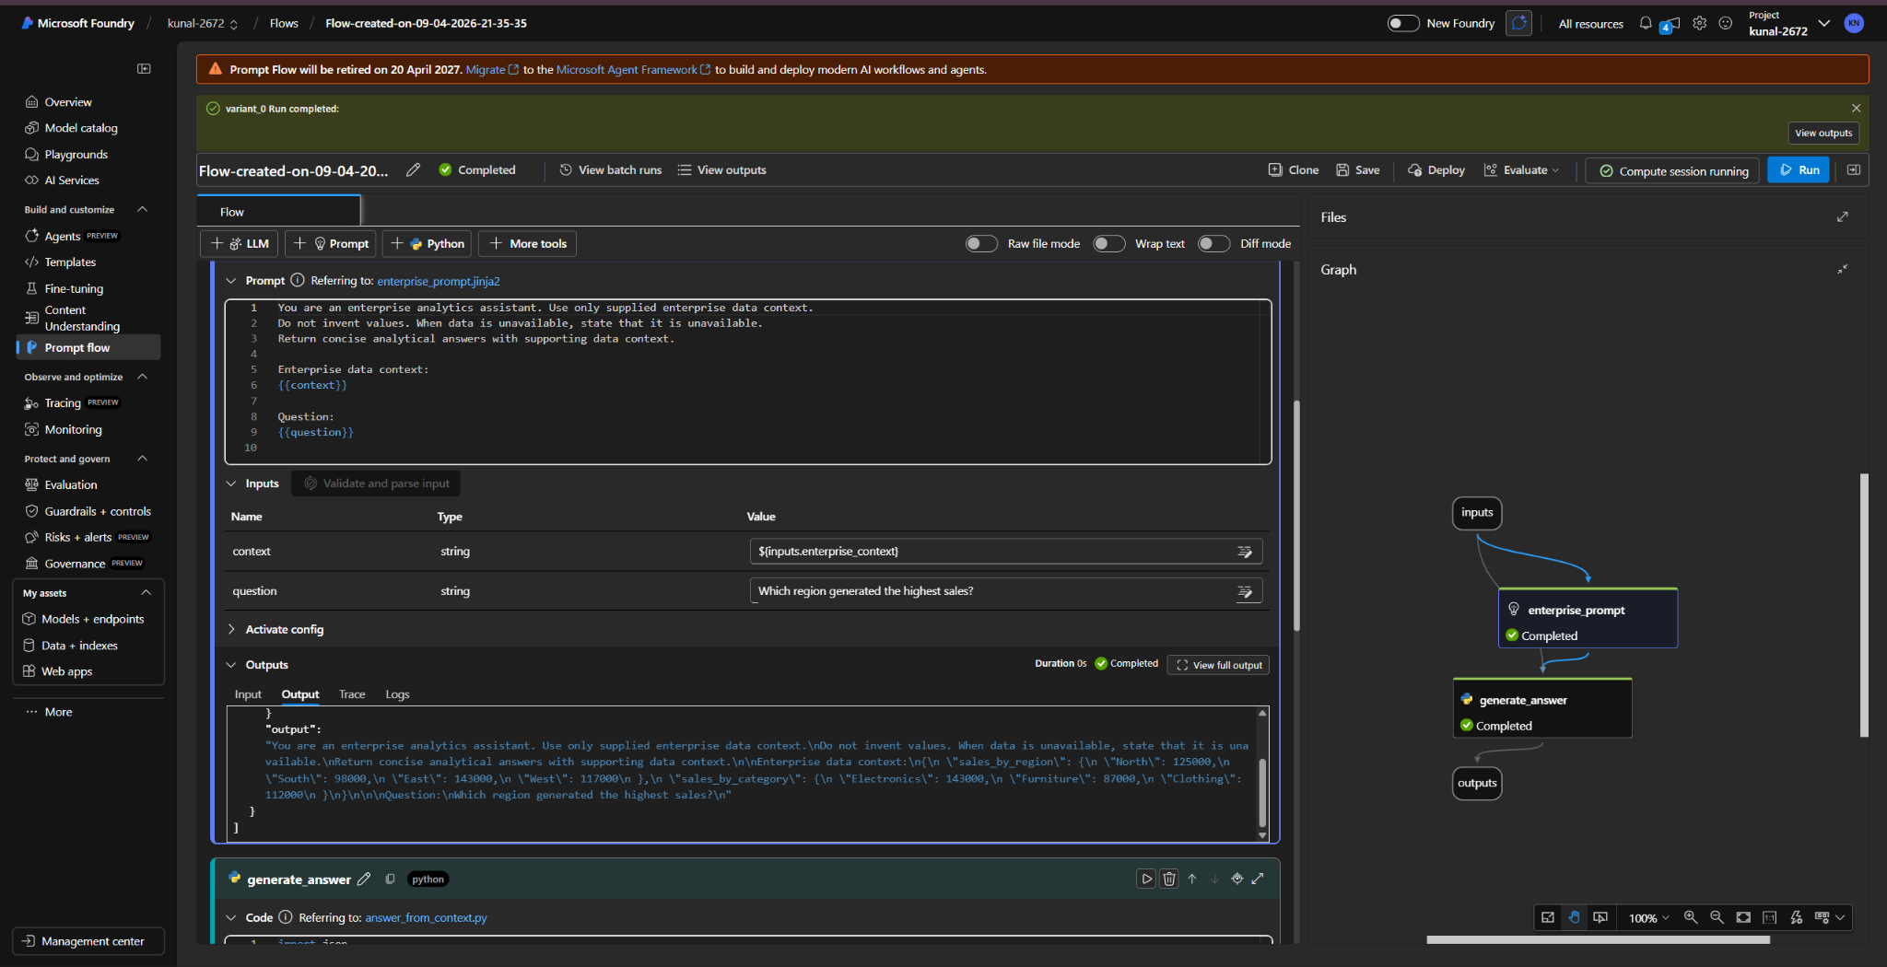
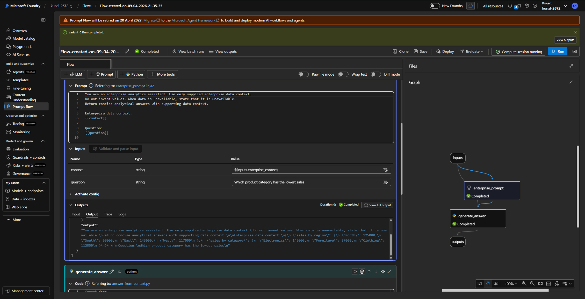

STEP 16 — Review Copilot Governance and User Scope
Path:
Microsoft Fabric → Admin Portal → Tenant settings → Copilot / AI governance
Do this:
- Open Microsoft Fabric.
- Open Settings ⚙️.
- Select Admin portal.
- Open Tenant settings.
- Search for Copilot or AI.
- Review the available governance controls related to:
  - Copilot
  - AI
  - Data access
  - User access
  - Audit
  - Tenant governance
- Do not change any tenant-wide setting. We only need to review and record what is configured unless your instructor explicitly asks you to modify something.
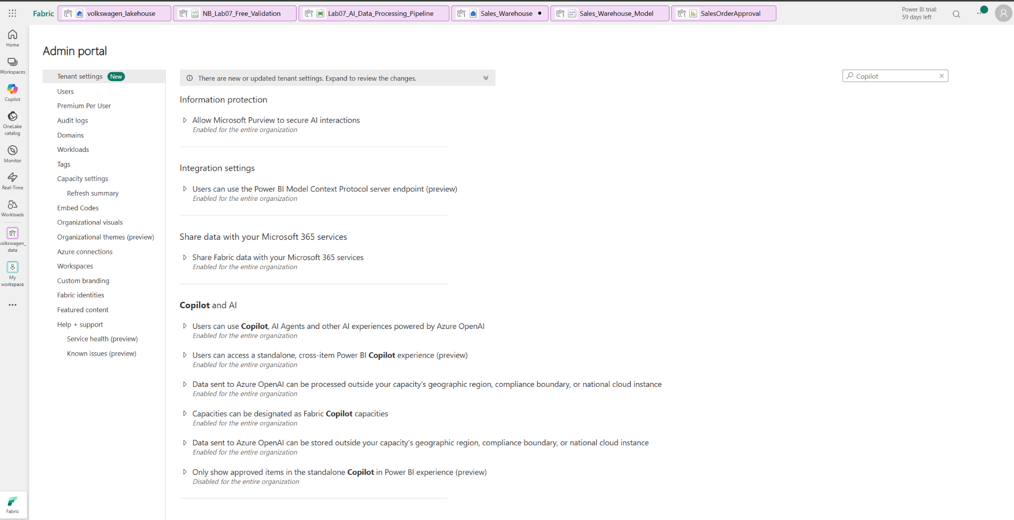

STEP 17 — Validate Audit / Activity Evidence
Path: Microsoft/Fabric approved Audit or Activity Logs → search/filter
- Search for lab activity using the user, date, workspace and Copilot/AI activity filters.
- Locate actions corresponding to notebook Copilot, Power BI/Copilot, AI configuration or other lab activity.
- Capture evidence while removing/avoiding confidential user information.
Expected Result: Relevant AI/Copilot activity is traceable in approved audit logs.
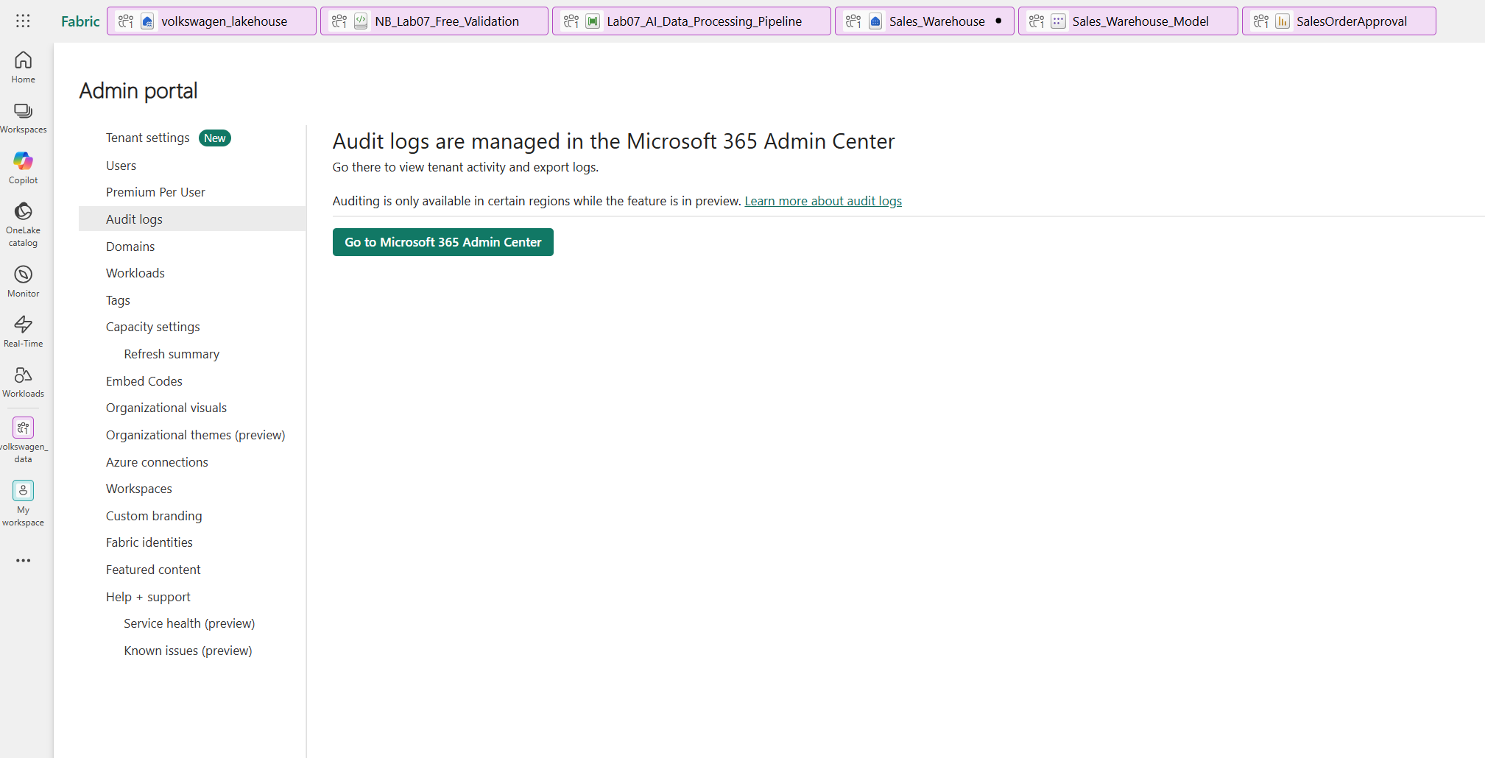

STEP 18 — Execute Final End-to-End AI Query
Path: Power BI report → Copilot
- Ask: 'Using the enterprise sales data, identify the highest-performing region, top product category, total revenue and average order value. Use only connected data and clearly identify any unavailable information.'
- Validate each returned value against the report/semantic model and the validated Warehouse results.
- Record any mismatch or unsupported claim and correct the underlying prompt/model/query before finalizing.
Expected Result: Final answer is grounded, traceable and consistent with validated analytics.
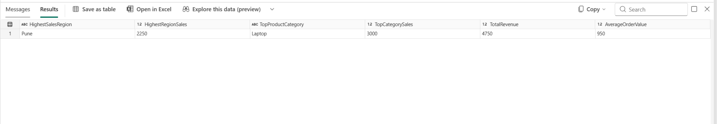
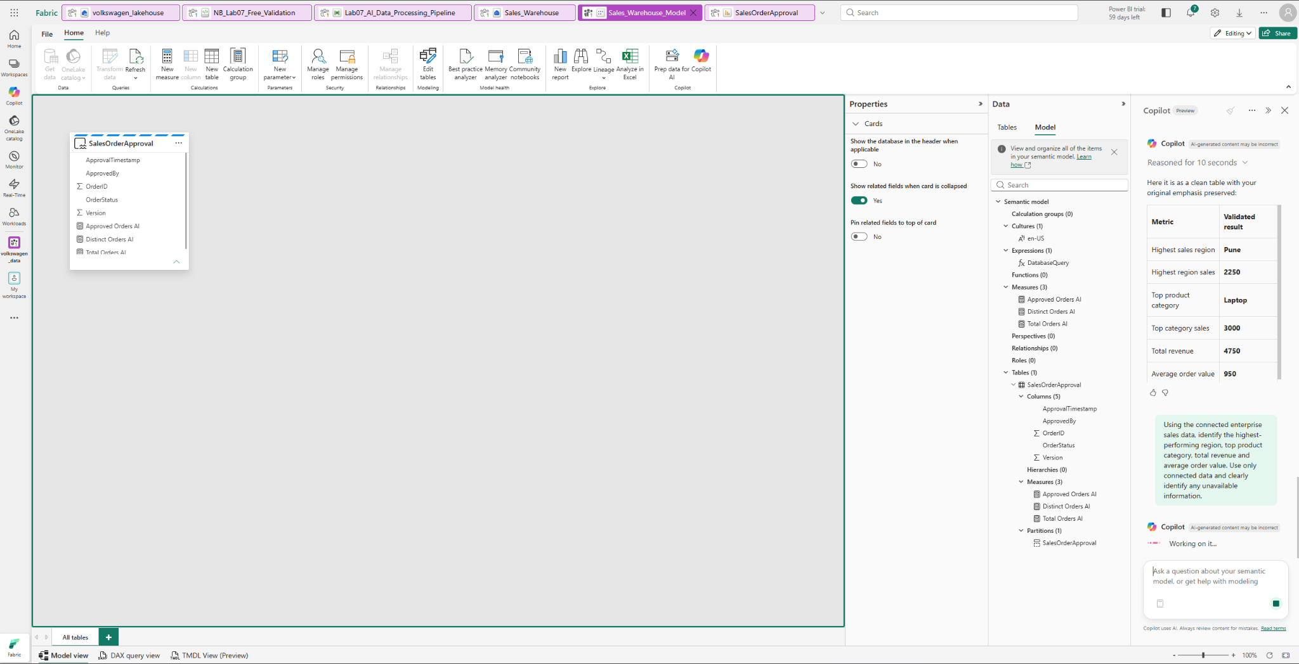

Coverage Matrix
Module Coverage | Compact Lab Steps
Copilot Assist in Fabric | Steps 01–05
Copilot code generation for PySpark / Notebook | Steps 02–04
Copilot pipeline logic | Step 05
T-SQL generation and optimization | Steps 06–07
DAX generation and validation | Steps 08–09
Power BI Copilot / natural-language Q&A | Steps 10–12
Synonyms / business terminology optimization | Step 11
Prompt engineering for enterprise data | Step 12
OneLake / Fabric data grounding | Step 13
Unsupported data / hallucination resistance | Step 14
Azure AI Foundry / Prompt Flow | Step 15
Copilot governance and user scope | Step 16
Audit trails / activity validation | Step 17
Responsible AI controls | Steps 14, 16–17
End-to-end AI-assisted workflow | Steps 18

Final Project State
Enterprise Fabric Data → Lakehouse → Notebook/Pipeline + Copilot → Warehouse/T-SQL → Semantic Model/DAX → Power BI/Copilot → Natural-Language Q&A → OneLake-grounded AI → Azure AI Foundry Prompt Flow + Governance/Audit → Responsible AI → Final validated answer.

Important Execution Rule
The 20-step limit applies only to the numbered execution steps. Prerequisites and setup are Step 0 and must be completed before Step 01. Do not create sample business data. Use only instructor-provided/existing enterprise Fabric assets and the approved AI configuration.

